

**Information Technology Institute**

**Information Systems Department**

**Data Management Track**

**Hotels One View**

**Under Supervision of:**

**Eng. Rana Salah**

**Eng. Ahmed Abuelkheir**

Information Systems Department Head,

Data Management Track,

Information Technology Institute.

**June 2021**

**By:**

Ahmed Shaban

Esraa Ahmed

Mustafa Mamdouh

Sara Ashraf

# Acknowledgement

The success and final outcome of this project required a lot of guidance and assistance from many people, and we are extremely privileged to have got this all along the completion of our project. All that we have done is only due to such supervision and assistance and I would not forget to thank them.

I respect and thank Eng. Rana Salah, Eng. Ahmed Abuelkhier Eng. Mostafa Madkour and Eng. Soaad El-Sayed for giving us all support and guidance which made us complete the project duly. we owe our deep gratitude to them, they took keen interest on our project work and guided us all along, till the completion of our project work by providing all the necessary information for developing a good system.

I am thankful to and fortunate enough to get constant encouragement, support and guidance from all Teaching and Technical staffs of Information Systems which helped us in successfully completing our project work.

# Abstract

When it comes to analyzing your data, relying on manual methods - i.e. using Excel spreadsheets or Google Sheets - takes too much time and is often inaccurate, fraught with human error. Hotel owners looking to accurately and efficiently improve business performance should consider [implementing an automated business intelligence (BI)](https://www.smartdecisionguides.com/hotelbi-nev/)solution.

BI reporting and analytics quickly integrate data from your property management systems as well as other potential external sources. In seconds you can easily compare historic, real-time, and predictive analytics, creating big picture to deeply granular views of your business. By applying BI to real-life situations, you will better understand critical pain points to make impactful improvements that optimize revenue and help grow your business.

Business Intelligence tools are designed exclusively for analysis; to provide fast and widespread access to accurate information and insight. Through dashboards, reports and analytics. users can explore their business – both historical performance and future activity.

BI automates reporting, turning report producers into information consumers who can in turn analyze and apply their findings to influence business results. Business Intelligence is about gathering data from a variety of sources and then utilizing technology to serve information to decision-makers in ways that help them to understand where opportunities exist within their business.

# List of Figures

Figure 1 ………………………………………………………..……………. 10

Figure 2 ………………………………………………………………………. 10

Figure 3 Data Warehouse Model ………………………………………………16

Figure 4 ETL Job ……………………………………………………………….17

Figure 5 ETL Job ……………………………………………………………….17

Figure 6 ETL Job ……………………………………………………………….17

Figure 7 ETL Job ……………………………………………………………….18

Figure 8 ETL Job ……………………………………………………………….18

Figure 8 ETL Job ……………………………………………………………….18

Figure 8 ETL Job ……………………………………………………………….19

Figure 10 Visualization ………………………………………………………....21

# 

# List of Abbreviations

* BI Business Intelligence
* DWH Data Warehouse
* ETL Extract – Transform – Load
* SQL Structured Query Language
* SSMS SQL Server Management Studio
* IPaaS Integration Platform as a Service

**Table of Contents**

Acknowledgement i

Abstract ii

List of Figures iii

List of Abbreviations iii

1- Introduction 5

1.1 Motivation 5

1.2 Problem Definition 6

1.3 Objective 7

1.4 Document Organization 8

2- Architecture and Technology Stack 4

2.1 Data Pipeline 10

2.2 Technology Stack 10

2.2.1 Data Source 13

2.2.2 Data Extraction 14

2.2.3 Data Store 14

2.2.4 Data Visualization 15

3- Source System Exploration 17

4- Data warehouse Modelling 19

5- ETL Jobs 25

6- KPIs and Data Visualization 34

6.1 KPIs

6.2 Visualization

7- Challenges

8- Conclusion 34

9- Future Work 35

References 36

# Introduction

## **Motivation**

Throughout the hotel industry, we suffer from a lack of critical, timely information on the most fundamental aspects of our business. We attempt to address this deficiency through manual reporting; printing reports from operational systems, keying numbers into spreadsheets and emailing files daily. This turns some of the industry’s brightest minds into simple report producers. BI automates, accelerates and enhances reporting, turning these report producers into information consumers who can analyze and apply their findings to take advantage of business opportunities while they still exist.

[**Business intelligence**](https://www.altexsoft.com/blog/business/complete-guide-to-business-intelligence-and-analytics-strategy-steps-processes-and-tools/)**(BI)** exists to address the problem of capturing and understanding data. It is a set of tools made for collecting data from multiple sources and transforming raw information into a meaningful form.

We will look at the specifics of using BI in the hotel industry. We will define the peculiarities of business intelligence for hospitality, the benefits it gives to the businesses, and the pitfalls of integration with industry-specific systems. We will also have a look at the providers’ market for a clear view on the functionality offered.

## **Problem Definition**

1. **Poor Performance Management**

Over the years, it becomes harder to make well informed performance, long-term and strategic decisions quickly and efficiently.

This is where hotel business intelligence comes in. It gives you relevant and deep insights into how your business is performing today.

1. **Losing Customers**

[Business intelligence tools for hotels](https://traqq.com/) give valuable insight into guest behavior. It uses collected data to perform analysis and to determine how your guests think.

This analysis gives you the necessary tools to create guest profiles based on their history, preferences, interests, and such likes.

As a result, any hotel can deliver a personalized experience to its customers and build long-term relationships.

1. **Slow Market Response**

This is one of the easiest ways to lose money and guests.

Hotel business intelligence solutions help you study market trends and analyze how it affects your guests’ behaviors.

You can even view these reports on a daily basis instead of waiting until the end of the quarter. If market shifts occur unexpectedly, you are better prepared to make quick decisions.

Addressing these issues will not only boost productivity, but also increase revenue.

## **Objective**

1. **Improve decision making.**

Hotel business intelligence lets you take all the data and use it to run your hotel more efficiently. The BI solutions help you in decision making and make it possible to compare historical data with current data.

Above all, you can perform predictive analysis by comparing different metrics across any timeline. Parsing the data collecting through BI helps you figure out when to intervene and take necessary actions. You can also determine what to do to increase profit or avoid losses and errors in the future.

1. **Improve marketing and revenue management strategy.**

According to hotel type and rooms revenue.

Thankfully, hotel business intelligence makes raw data analysis easy and helps you find out which of these booking sources is the most lucrative option.

Therefore, it becomes convenient for your management team to determine what marketing strategy to employ and which demographic to target.

1. **Adapt to latest trends.**

BI makes it easy to identify trends early enough.

This makes it possible to adjust your strategy in a way that’ll maximize your growth potential. It helps your business to scale with less difficulty.

Identifying patterns on time help you set your business in the right position for success.

## **Document Organization**

* **Chapter 2:**

This chapter has the Architecture and Technology Stack of the project.

It represents the project pipeline and discusses each tool in detail and that reveal the reason behind using each technology in our data pipeline.

* **Chapter 3:**

This chapter discuss the source system and explore the whole tables and attributes according to we will take a decision on how we will design our data model which will be discussed in the next chapter.

* **Chapter 4:**

This chapter includes a detailed description of all the functions in

the project, a detailed description of all the techniques and

algorithms implemented, description of the new technologies

used in implementation and description of AR UI design and

testing procedures.

* **Chapter 5:**

This chapter includes a complete summary of the whole project along with the results obtained.

The future work and what can be done in the future to improve the performance of the project and what additional functions could be added.

## **2- Architecture and Technology Stack**

## **2.1 Data Pipeline**

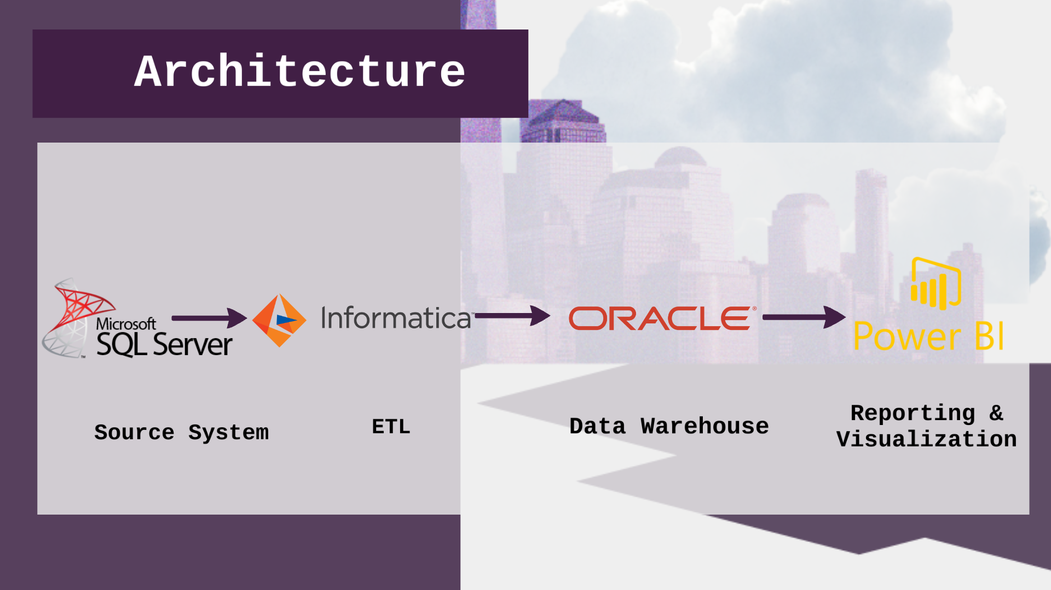

Figure 1 - Project Architecture

Our Data Pipeline goes as following:

First of all, we access the data via SQL Server Management Studio as a source system after that we apply ETL process using Informatica Integration Platform as a Service (iPaaS Technology) by applying ETL jobs then, we load the results into Oracle Developer Studio which contains the physical implementation of our logical data warehouse model Finally, we perform analysis and visualize results using Power BI.

### **2.2 Technology Stack**

### 

Figure 2 - Technology Stack

### **2.2.1 Data Source**

**SQL Server Management Studio (SSMS).**

As a Source System we have SQL Server Database.

SQL Server Management Studiois a software application first launched with [Microsoft](https://en.wikipedia.org/wiki/Microsoft) [SQL Server 2005](https://en.wikipedia.org/wiki/Microsoft_SQL_Server) that is used for configuring, managing, and administering all components within [Microsoft SQL Server](https://en.wikipedia.org/wiki/Microsoft_SQL_Server). It is the successor to the Enterprise Manager in SQL 2000 or before. The tool includes both script editors and graphical tools which work with objects and features of the server. A central feature of SSMS is the Object Explorer, which allows the user to browse, select, and act upon any of the objects within the server. It also shipped a separate Express edition that could be freely downloaded, however recent versions of SSMS are fully capable of connecting to and manage any SQL Server Express instance. Microsoft also incorporated backwards compatibility for older versions of SQL Server thus allowing a newer version of SSMS to connect to older versions of SQL Server instances.

## **2.2.2 Data Extraction**

**a. Informatica Integration platform as a service (iPaaS)**.

As an ETL Tool we have Informatica iPaaS

is a hosted service offering in which a third-party provider delivers infrastructure and middleware to manage, develop and integrate data and applications? Think of iPaaS as a cloud-friendly alternative to traditional forms of data integration: you can bring together on-premises and cloud-based applications and data to create a single source of trusted data with less effort and expense. It offers a fully managed service with continuous, automatic system updates in the cloud and eliminates the need of manual upgrades and maintenance of software. In today's multi-cloud world, data-driven organizations need a robust iPaaS that can support any type of users, any data, and any integration pattern for maximum flexibility and scalability.

**b. Difference between ETL jobs and IPaaS:**

The big difference between ETL and IPaaS is the ability to integrate data in real-time.  Digitally transformed business processes have a strong dependency on technology to enable productivity and efficiency as well as data to drive decision making.  IPaaS solutions provide the capabilities to connect all of your IT systems together and enable the orchestrated movement of data across your organization – whether that be real-time transaction processing, operational analytics for process control, or movement of data into your data warehouse for archival and big-data analytics.

### **2.2.3 Data Store**

**Oracle Developer Studio**.

Our data warehouse model was built on Oracle Database.

It’s formerly named Oracle Solaris Studio, Sun Studio, Sun WorkShop, Forte Developer, and SunPro Compilers, is [Oracle Corporation](https://en.wikipedia.org/wiki/Oracle_Corporation)'s flagship software development product for the [Solaris](https://en.wikipedia.org/wiki/Solaris_(operating_system)) and [Linux](https://en.wikipedia.org/wiki/Linux) [operating systems](https://en.wikipedia.org/wiki/Operating_system). It includes optimizing C, C++, and Fortran [compilers](https://en.wikipedia.org/wiki/Compiler), libraries, and performance analysis and debugging tools, for Solaris on SPARC and x86 platforms, and Linux on x86/x64 platforms, including multi-core systems.

### **2.2.4 Data Visualization**

**Power BI**.

As a visualization tool we rely on Power BI it is a [business analytics](https://en.wikipedia.org/wiki/Business_analytics) service by [Microsoft](https://en.wikipedia.org/wiki/Microsoft). It aims to provide interactive [visualizations](https://en.wikipedia.org/wiki/Data_visualization) and [business intelligence](https://en.wikipedia.org/wiki/Business_intelligence) capabilities with an interface simple enough for end users to create their own reports and dashboards. It is part of the Platform. It provides [cloud](https://en.wikipedia.org/wiki/Cloud_computing)-based BI (business intelligence) services, known as "Power BI Services", along with a desktop based interface, called "Power BI Desktop". It offers [data warehouse](https://en.wikipedia.org/wiki/Data_warehouse) capabilities including [data preparation](https://en.wikipedia.org/wiki/Data_preparation), [data discovery](https://en.wikipedia.org/wiki/Data_discovery) and interactive dashboards.

**3- Source System Exploration**

**3.1 Microsoft SQL Server as a source system.**

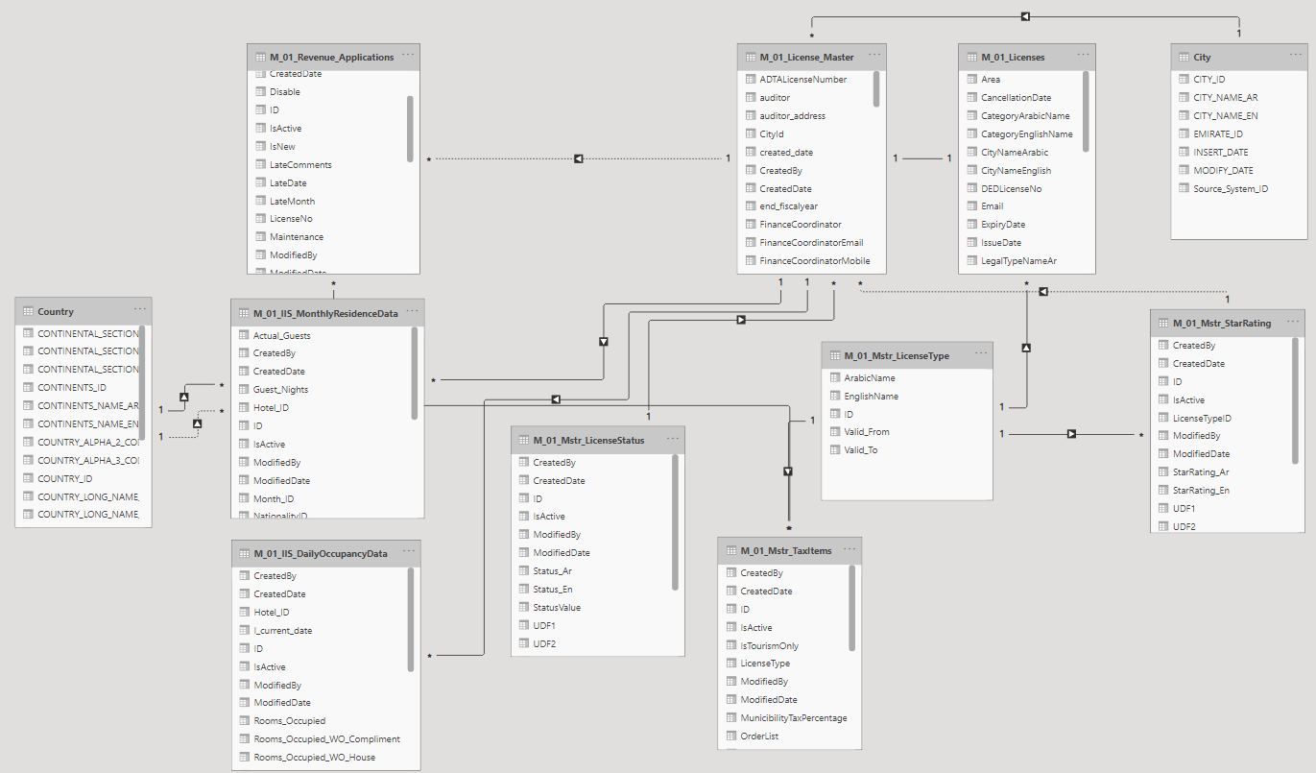

Figure 2

Figure

**3.2 Tables Description**

**M_01_Mstr_LicenseStatus**

This Table describes the status of license if it active or inactive, the date of its creation and who created it also The date of the last modification and who made it and is it valid or has it expired.

**M_01_Licenses**

It contains everything related to licenses such as Licensesid , DEDLicenseNo , LicenseNumber and contains information about all hotel for example hotel name ,location , manager name , all contacts for each hotel.

**M_ License_Master**

Contains same information as licenses table but in more detail about the other.

**M_01_Mstr_TaxItems**

It describes everything related to Tax such as Tax description, percentage, when it created, the date of the last modification.

**M_01_Mstr_LicenseType**

There are in it the licenses Types (Hotels, Hotel Apartments, Resorts, Hotel Management, Travel Office, Restaurant, Tourist Camps) also the expiration date of it.

**City**

It contains city_ID , city Name Arabic and English format , insert date and also modification date .

**Country**

There are many attributes such as ID, country name in Arabic and English, The date of insertion and modification

**M_01_IIS_MonthlyResidenceData**

It contains licenses expire date , type, all information about each hotel.

**M_01_IIS_MonthlyData**

Data for each hotel is aggregated by month.

**M_01_Mstr_StarRating**

It contains rating for each hotel.

**3.3 Results of exploration:**

* Hotel ID is a FK. for LicenseNumber on Table M_01_Licenses but after splitting (first 3 characters) Prefix of LicenseNumber.
* Nationality and residence will  refer to the country.
* ADTALicenseNumber on Table M_01_Licenses_master is a ref. for LicenseNumber Table M_01_Licenses.
* ADTALicenseNumber in LicenseNumber_Master ref. HotelID in all Facts after cleaning.
* LicencseActive in LicenseNumber_Master is ref. for License_Status (IsActive is not important).
* License_Type in LicenseNumber_Master ref. ID in License_Type
* CityID in LicenseNumber_Master ref. ID City.
* ResedenceID, NationalityID in LicenseNumber_Master ref. ID Country.
* Rating in LicenseNumber_Master ref. ID StarRating.

* 1. **Data Warehouse Modelling**
* Data warehouse modeling is the process of designing the schemas of the detailed and summarized information of the data warehouse. The goal of data warehouse modeling is to develop a schema describing the reality, or at least a part of the fact, which the data warehouse is needed to support.

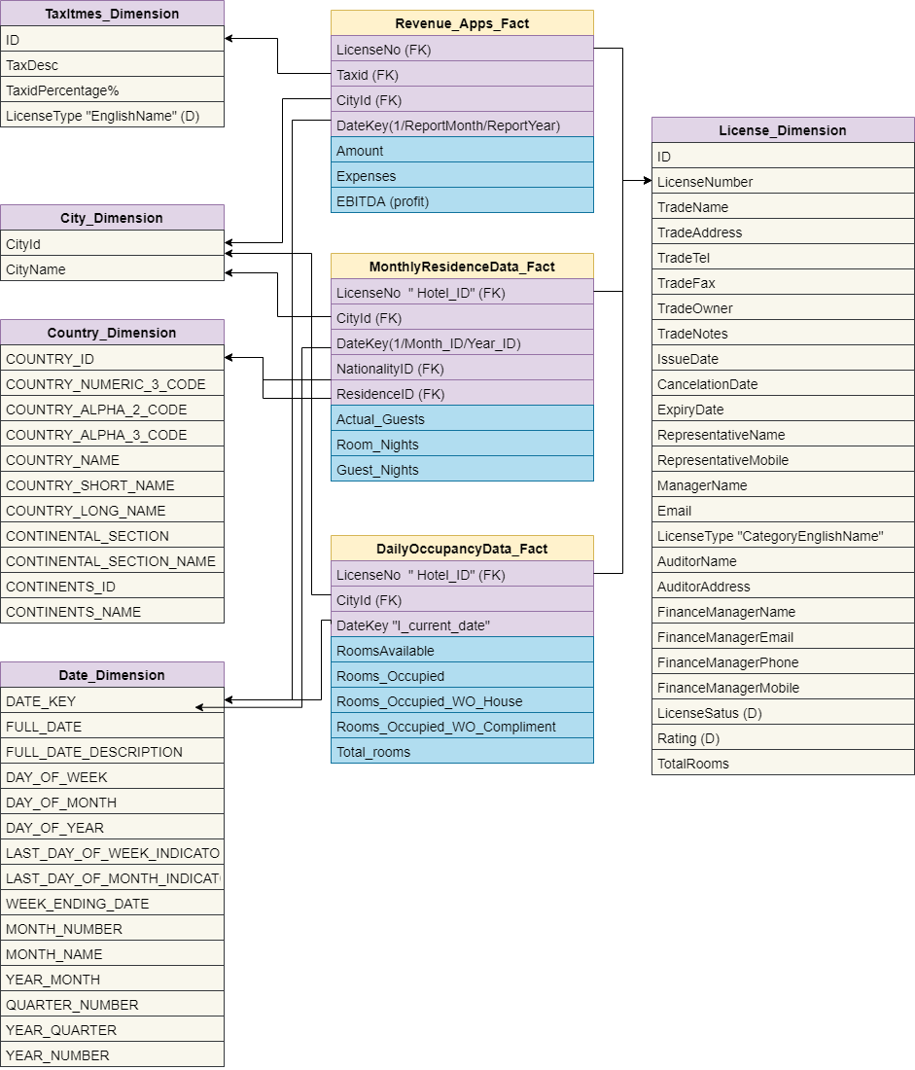

Data Warehouse Modeling

* 1. **ETL Jobs**

Let's take a look at every ETL job we've done.

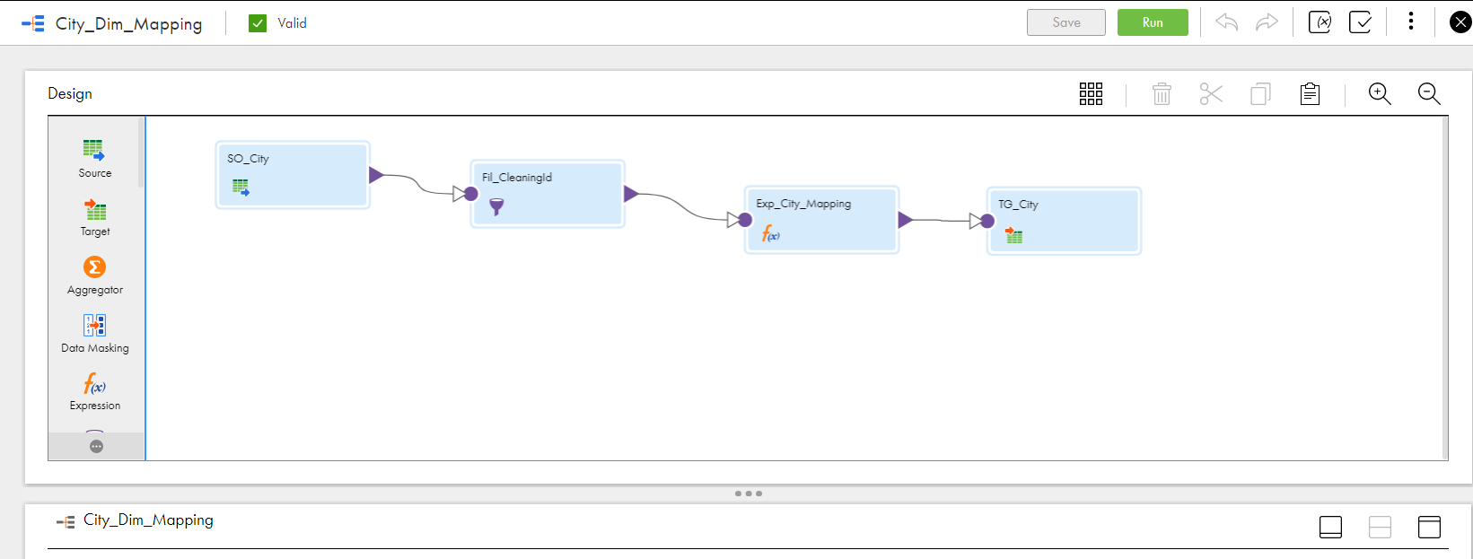

2.

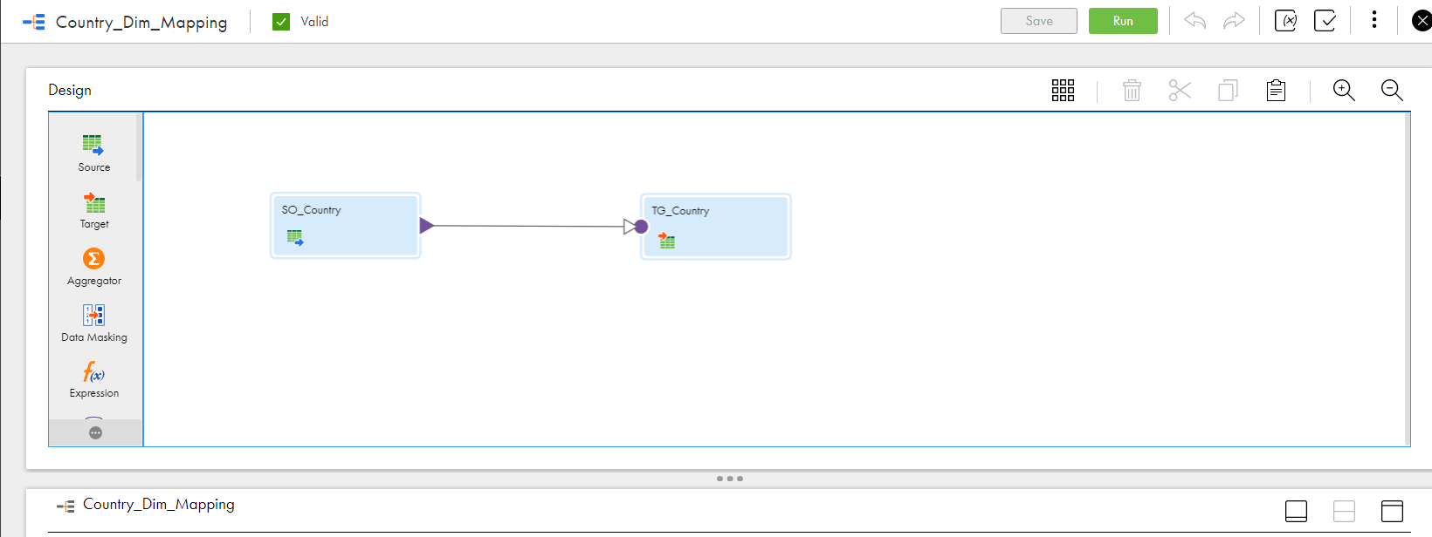

3.

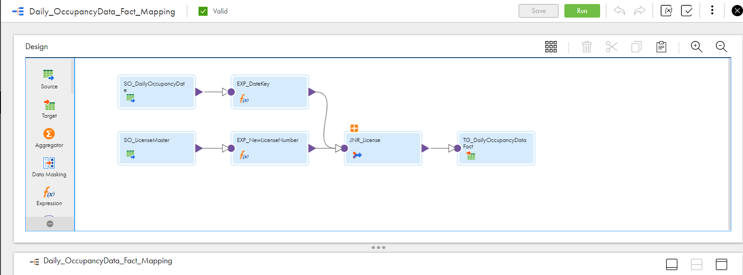

4.

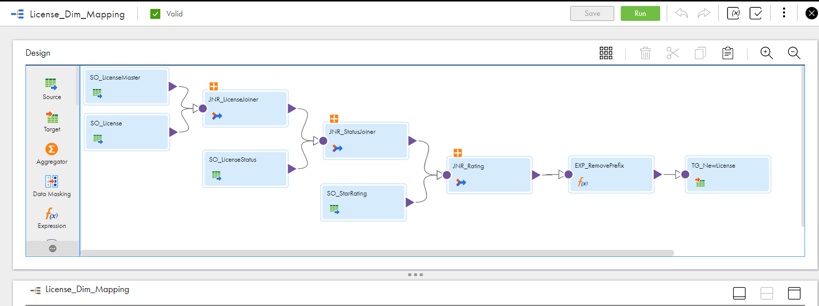

5.

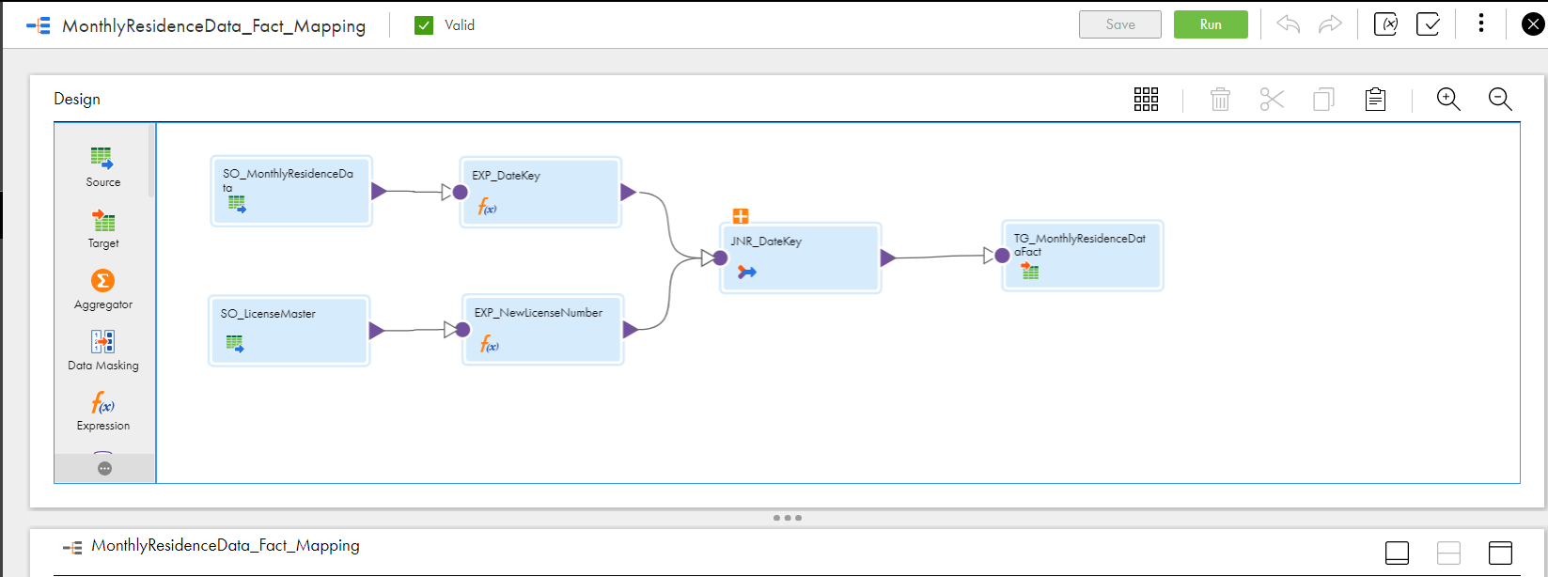

6.

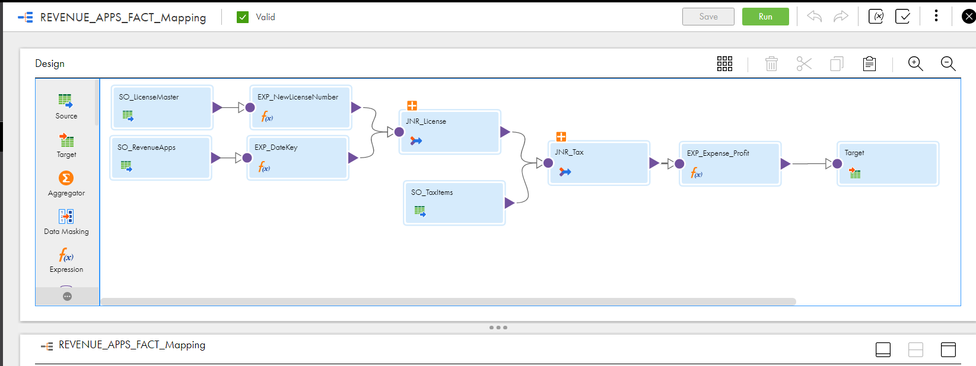

7.

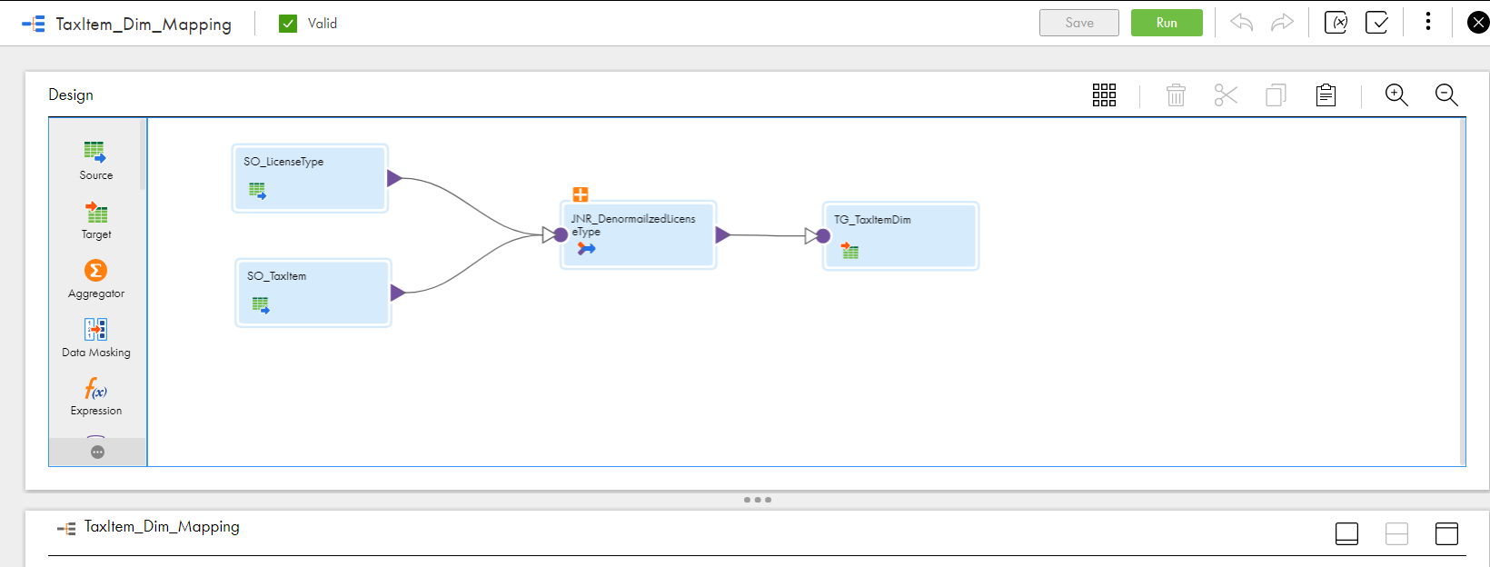

# KPIs and Data Visualizations

**6.1 –** **KPIS**

**a. EBITD Earnings Before Interest, Taxes and Depreciation**

**(Per Hotel Monthly)**

As the name says, it is measured by taking your hotel’s expenses before interest, tax, amortization, and depreciation, and subtracting them from your hotel’s total amount of revenue.

To calculate:

**EBITDA = Revenue – Expenses\***

**Expenses = Tax Percentage/100 * Amount**

**It’s importance and usage:**

* This is a measure of how profitable your hotel is with respect to its operations, that is, the earnings and income of your hotel against the expenses on its requirements.
* This hotel KPI is very essential as it indicates your hotel’s financial performance, and your ability to assess day-to-day routine operations and functionalities.
* It also eliminates the impact of financial and accounting aspects, which may affect financial results, thus, giving you a chance to compare your YOY performance effectively.

**Column names and source from database:**

|  |  |  |
| --- | --- | --- |
| Table Name | Column Name | Filter By |
| M_01_Revenue_Applications | Amount | ReportYear and ReportMonth  (Drill Down) |
| M_01_Mstr_TaxItems | ID – TaxPercentage | LicenseType |

**b. Hotel Occupancy Rate**

The occupancy rate is the number of total rooms occupied out of the total rooms available in your hotel. Analyse occupancy rate daily, weekly, yearly or monthly to see how well your hotel is performing.

To calculate:

**Occupancy rate = (Number of Occupied Rooms/total available Rooms) *100**

**It’s importance and usage:**

* The hotel occupancy rate is dependent on the number of bookings you get, and your revenue is dependent on the occupancy.

**Column names and source from database:**

|  |  |  |
| --- | --- | --- |
| Table Name | Column Name | Filter By |
| M_01_IIS_DailyOccupancyData | Rooms_Occupied , Total_rooms | LicenseType |

**c. Total number of hotels per city**

  We want to know the number of hotels in each Country, City

**d. Knowing types of nationalities**

To find out the most visited nationalities in each hotel to provide more offers and services that suit their customs and traditions, as well as for the minority.

**6.2 -** **Visualizations**

Finally, all data is presented via user interfaces. These allow us to query data and visualize it.

We

-Profit

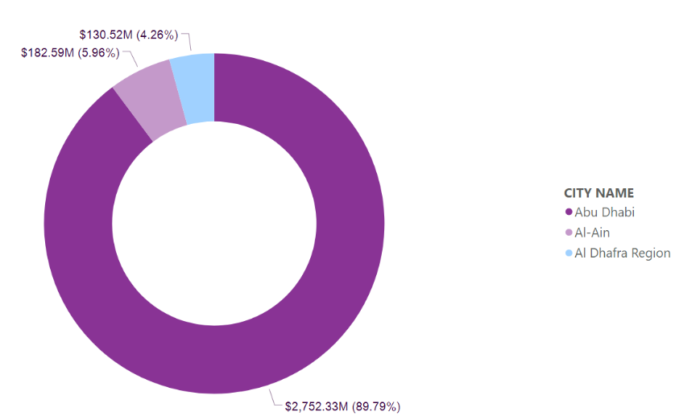

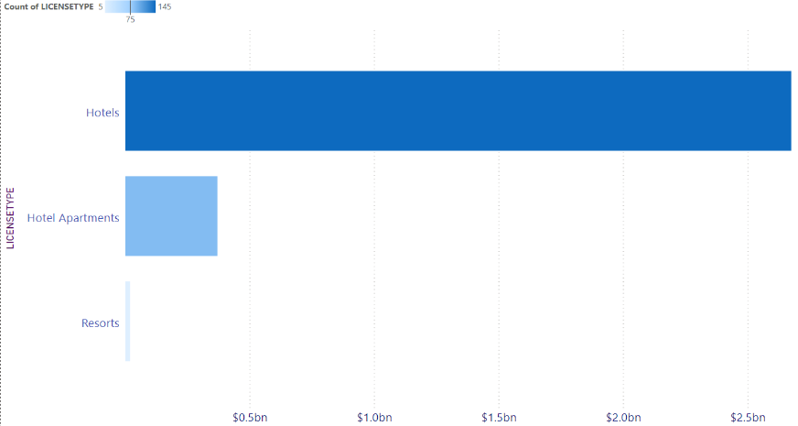

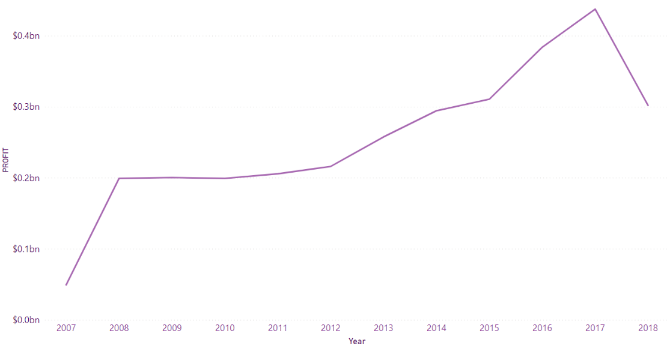

-Occupancy Rate

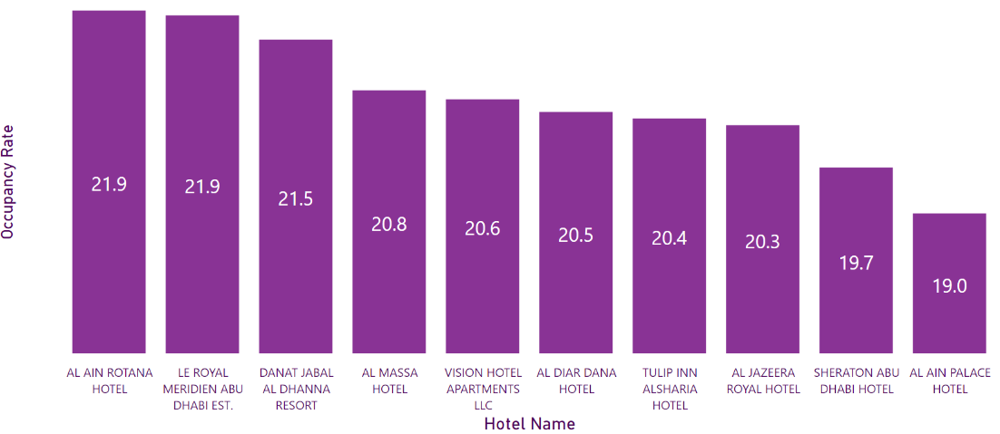

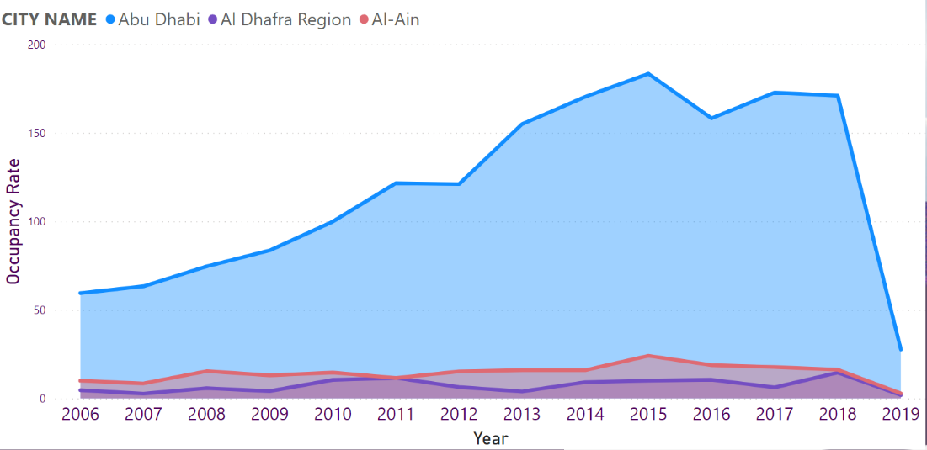

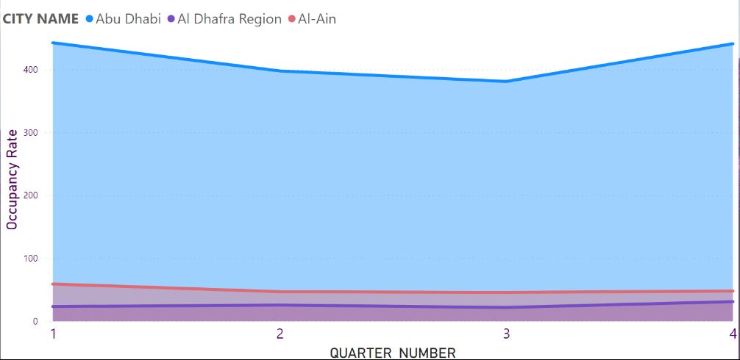

-Nationality

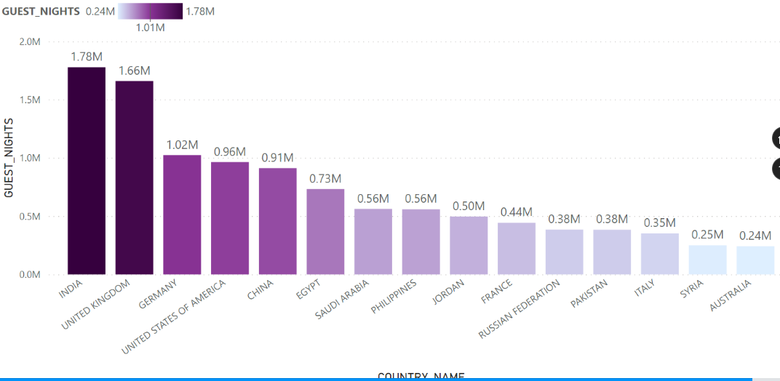

-Rating

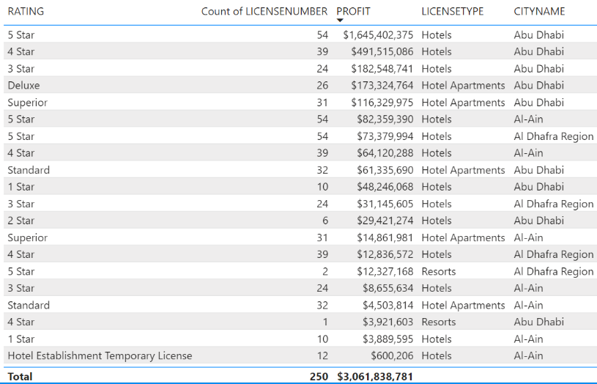

* 1. **Challenges**
* **Justifying the need for investing in BI**

The first challenge is trying to convince stakeholders as to why BI is a necessary investment.

It may feel unfamiliar to handle initially. In addition, you might feel discouraged by the idea of trying to integrate a new process into your business.

However, remembering the benefits and how it can give you a competitive advantage will help you surmount this hesitation.

* **Identifying the right data to use for analysis.**

which data to use for analysis and what purpose this data will serve.

It means that the data you choose to use will depend on what you’re trying to achieve following your analysis.

## 

## **Future Work**

* Replication

The primary benefits of data replication are disaster recovery and high availability of mission-critical applications. If the primary data source should fail, a replicate can be swapped in immediately. It also provides transactional consistency so that the data is up-to-date and consistent. Data replication tools can reduce the IT labor involved in creating and managing data replication transactions across the enterprise.

* Synchronization

Data synchronization prevents data conflicts, which can result in errors and low-quality, low-trust data. Synchronized, trustworthy data is essential for security, compliance, and a wide variety of operational functions. Organizations that can trust the quality of their data will enjoy higher performance, reputation, and cost-efficiency.

Given the importance of Replication and synchronization, we hope to apply them.

# References

Team, e., 2021. *Hotel Business Intelligence: Issues, Challenges, and Solutions*. [online] eZee Absolute. Available at: <<https://www.ezeeabsolute.com/blog/hotel-business-intelligence>/> [Accessed 22 June 2021].

Team, e., 2021. *Hotel Business Intelligence: Issues, Challenges, and Solutions*. [online] eZee Absolute. Available at: <[https://www.ezeeabsolute.com/blog/hotel-business-intelligence/>](https://www.ezeeabsolute.com/blog/hotel-business-intelligence/%3e%20) [Accessed 25 June 2021].